**TUGAS 10**

**PRAK11 Rating App**



Praktikum Pemrograman Berbasis Web - A

Nama :

Adelia Nurlina Putri 4521210059

**PROGRAM STUDI S1 TEKNIK INFORMATIKA**

**FAKULTAS TEKNIK**

**UNIVERSITAS PANCASILA**

**JAKARTA**

**2024**

1. **Project rating_app**
   1. **First Initialization**
2. Akses web <https://docs.flutter.dev/ui/layout/tutorial>
3. Buka Android Studio

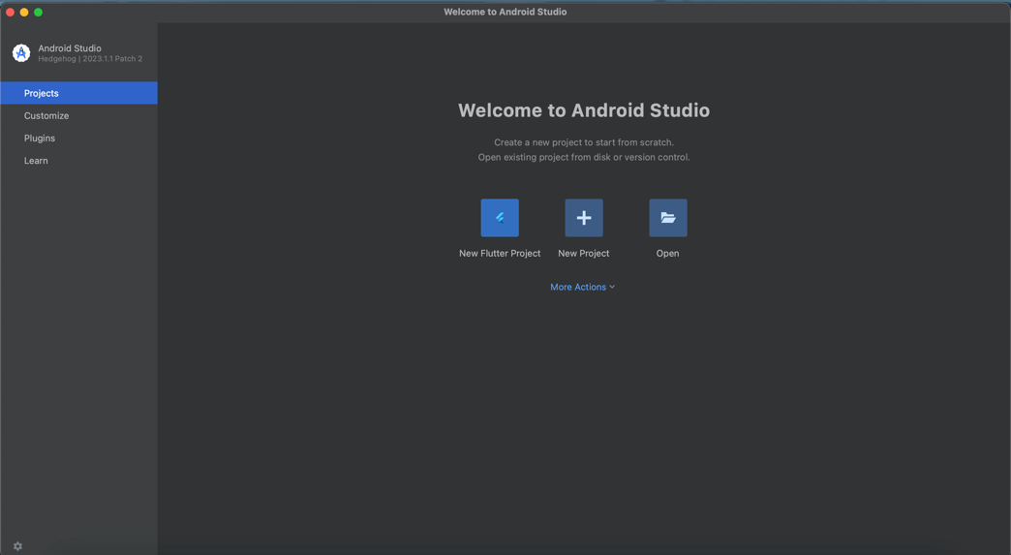

1. Pilih New Flutter Project -> Flutter -> Next

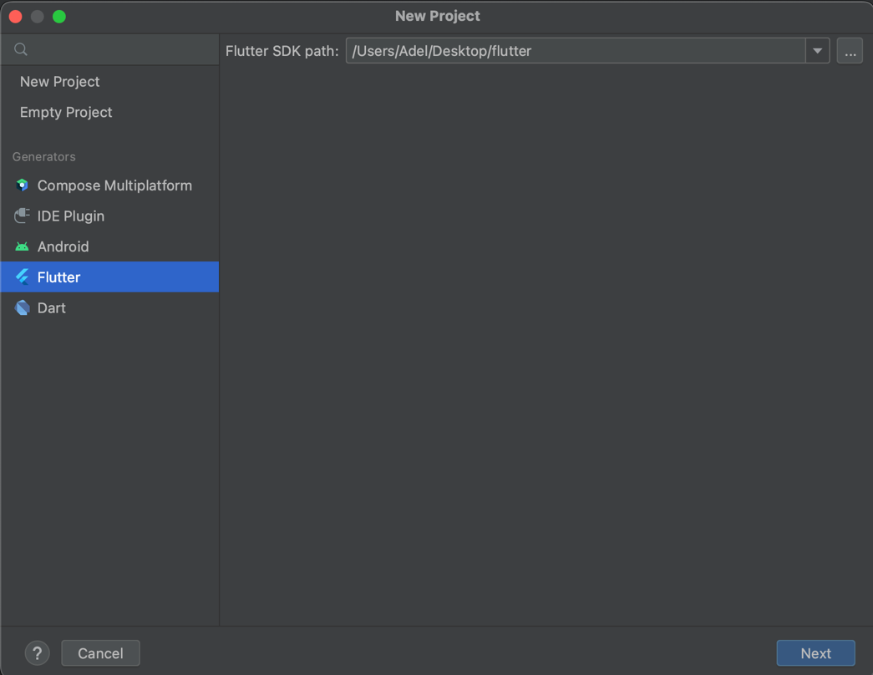

1. Isi form untuk nama project, tempat project, type, bahasa pemrograman, platforms dan lainnya -> Create

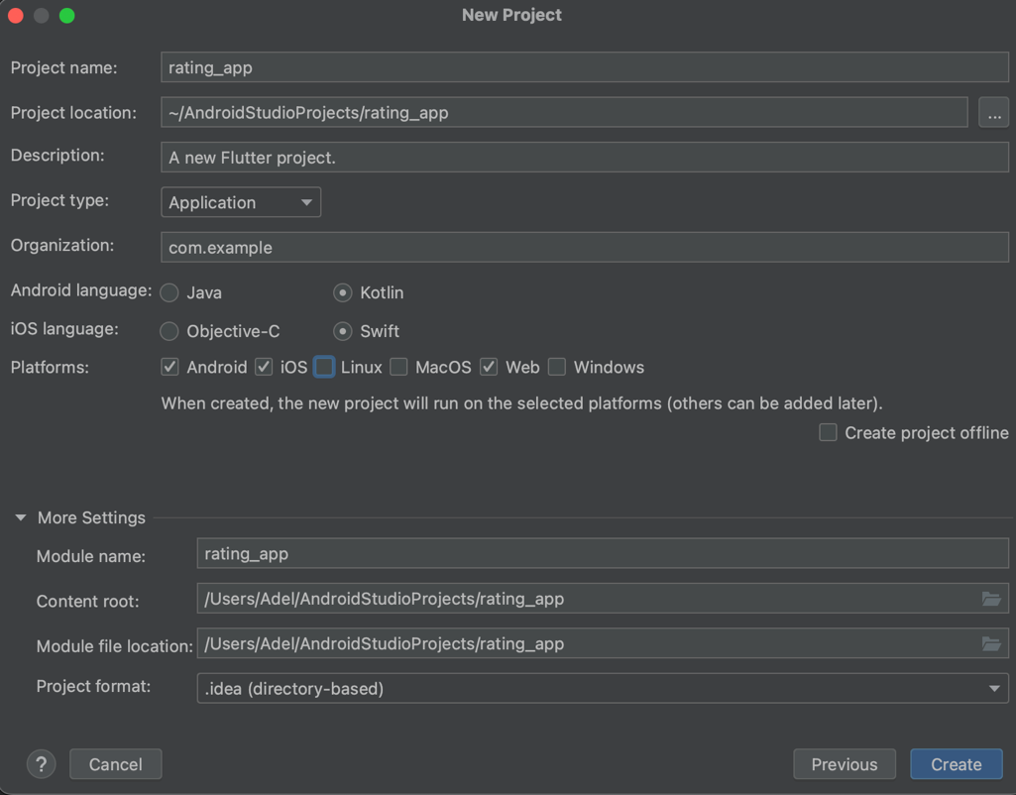

* 1. **Membuat App**

1. Buat file dengan susunan seperti berikut

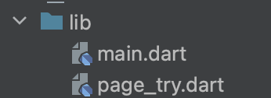

1. Add package ke pubspec.yaml

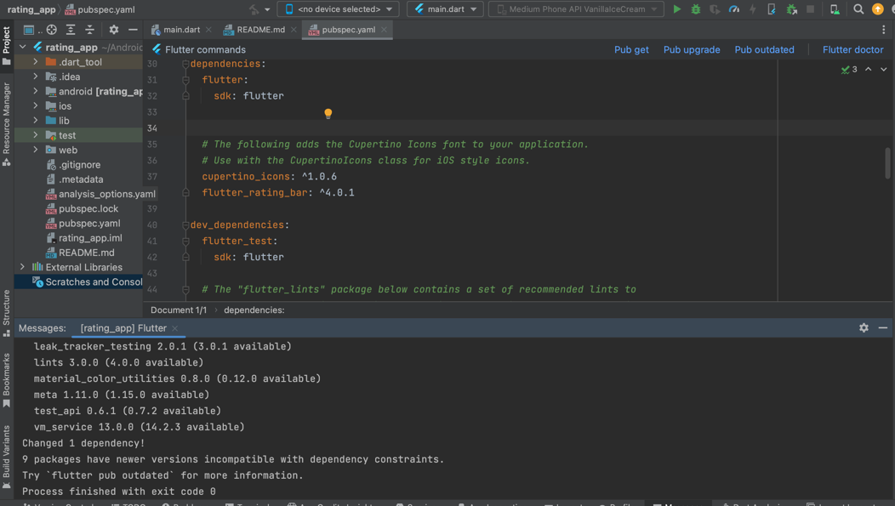

|  |
| --- |
| flutter_rating_bar: ^4.0.1  $ flutter pub add |

1. File page_try.dart membuat widget stateful RatingScreen

|  |
| --- |
| import 'package:flutter/material.dart';  class RatingScreen extends StatefulWidget {  const RatingScreen({super.key});  @override  State<RatingScreen> createState() => _RatingScreenState();  }  class _RatingScreenState extends State<RatingScreen> {  @override  Widget build(BuildContext context) {  return Scaffold();  }  } |

1. File main.dart

|  |
| --- |
| import 'package:flutter/material.dart';  import 'page_try.dart';  void main() {  runApp(MyApp());  }  class MyApp extends StatelessWidget {  @override  Widget build(BuildContext context) {  return MaterialApp(  title: 'Rating App',  theme: ThemeData(  primarySwatch: Colors.blue,  visualDensity: VisualDensity.adaptivePlatformDensity,  ),  home: RatingScreen(), // Set RatingScreen as the home widget  );  }  } |

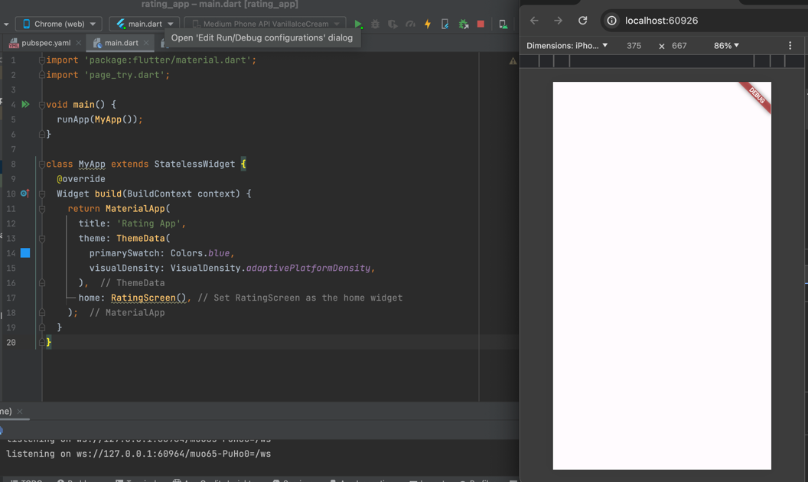

1. Tambah appbar, body, dan widget RatingBar.builder pada RatingScreen ()

|  |
| --- |
| import 'package:flutter/material.dart';  import 'package:flutter_rating_bar/flutter_rating_bar.dart';  class RatingScreen extends StatefulWidget {  const RatingScreen({super.key});  @override  State<RatingScreen> createState() => _RatingScreenState();  }  class _RatingScreenState extends State<RatingScreen> {  @override  Widget build(BuildContext context) {  return Scaffold(  backgroundColor: Colors.white,  appBar: AppBar(  backgroundColor: Colors.white,  elevation: 0,  centerTitle: true,  title: Text(  'Rating & Review',  style: TextStyle(  color: Colors.grey.shade700,  fontSize: 17,  fontWeight: FontWeight.w500,  ),  ),  ),  body: Column(  crossAxisAlignment: CrossAxisAlignment.start,  children: [  Center(  child: RatingBar.builder(  initialRating: 0,  minRating: 1,  direction: Axis.horizontal,  allowHalfRating: true,  itemCount: 5,  itemPadding: const EdgeInsets.symmetric(horizontal: 4.0),  itemBuilder: (context, _) => const Icon(  Icons.star,  color: Colors.amber,  ),  onRatingUpdate: (rating) {  print(rating);  },  ),  ),  ],  ),  );  }  } |

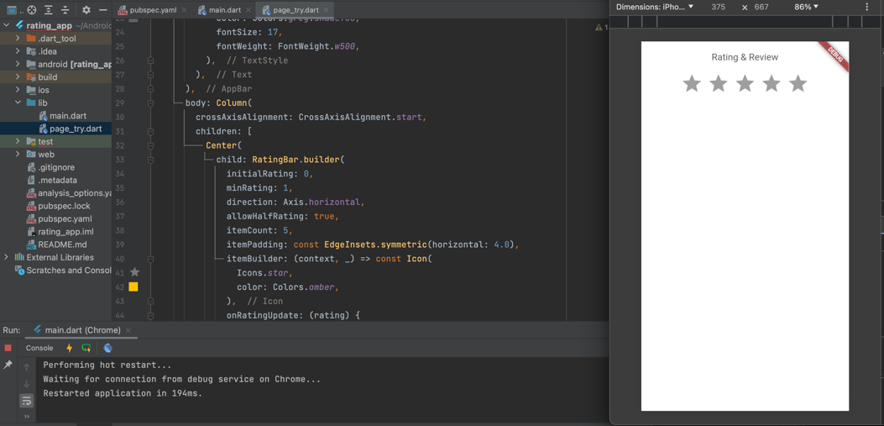

1. File add_screen.dart Tambahkan juga text dan container untuk informasi rata-rata rating dan total reviewnya serta running kembali aplikasinya

|  |
| --- |
| SizedBox(height: 10),  Center(  child: Text(  "Anda memiliki jumlah 0 penilaian dan\nrata-rata 0 penilaian",  textAlign: TextAlign.center,  style: TextStyle(  color: Colors.grey.shade500,  fontSize: 15,  fontWeight: FontWeight.w400,  ),  ),  ),  SizedBox(height: 20),  Row(  mainAxisAlignment: MainAxisAlignment.spaceEvenly,  children: [  Container(  height: 100,  width: MediaQuery.of(context).size.width * 0.45,  decoration: BoxDecoration(  color: Colors.grey.shade200,  borderRadius: BorderRadius.circular(10),  ),  child: Column(  mainAxisAlignment: MainAxisAlignment.center,  crossAxisAlignment: CrossAxisAlignment.center,  children: [  Text(  "0",  style: TextStyle(  color: Colors.grey.shade800,  fontSize: 35,  fontWeight: FontWeight.w600,  ),  ),  Text(  "Total Rating",  style: TextStyle(  color: Colors.grey.shade600,  fontSize: 13,  fontWeight: FontWeight.w400,  ),  ),  ],  ),  ),  Container(  height: 100,  width: MediaQuery.of(context).size.width * 0.45,  decoration: BoxDecoration(  color: Colors.grey.shade200,  borderRadius: BorderRadius.circular(10),  ),  child: Column(  mainAxisAlignment: MainAxisAlignment.center,  crossAxisAlignment: CrossAxisAlignment.center,  children: [  Text(  "0",  style: TextStyle(  color: Colors.grey.shade800,  fontSize: 35,  fontWeight: FontWeight.w600,  ),  ),  Text(  "Rata-Rata",  style: TextStyle(  color: Colors.grey.shade600,  fontSize: 13,  fontWeight: FontWeight.w400,  ),  ),  ],  ),  ),  ],  ),  SizedBox(height: 20),  InkWell(  onTap: () {},  child: Center(  child: Container(  height: 50,  width: MediaQuery.of(context).size.width * 0.91,  decoration: BoxDecoration(  border: Border.all(color: Colors.grey.shade300),  borderRadius: BorderRadius.circular(10),  ),  child: Padding(  padding: const EdgeInsets.only(left: 8.0, right: 10),  child: Row(  mainAxisAlignment: MainAxisAlignment.spaceBetween,  children: [  Text(  "Tulis ulasan anda disini",  style: TextStyle(  color: Colors.grey.shade600,  fontSize: 13,  fontWeight: FontWeight.w400,  ),  ),  Icon(  Icons.comment,  size: 16,  color: Colors.grey.shade600,  ),  ],  ),  ),  ),  ),  ),  SizedBox(height: 30),  Padding(  padding: const EdgeInsets.only(left: 18.0),  child: Text(  "Review Pengguna",  style: TextStyle(  color: Colors.grey.shade800,  fontSize: 20,  fontWeight: FontWeight.w500,  ),  ),  ),  SizedBox(height: 8),  Padding(  padding: const EdgeInsets.only(bottom: 10.0),  child: ListTile(  leading: const Icon(  Icons.star,  color: Colors.amber,  ),  title: Column(  crossAxisAlignment: CrossAxisAlignment.start,  children: [  Text(  'Rating: ',  style: TextStyle(  color: Colors.grey.shade700,  fontSize: 15,  fontWeight: FontWeight.w400,  ),  ),  Text(  'Ulasan: ',  style: TextStyle(  color: Colors.grey.shade700,  fontSize: 15,  fontWeight: FontWeight.w400,  ),  ),  ],  ),  ),  ),  Padding(  padding: const EdgeInsets.only(top: 3.0),  child: Container(  width: MediaQuery.of(context).size.width,  height: 1,  color: Colors.grey.shade200,  ),  ),  ],  ),  );  }  } |

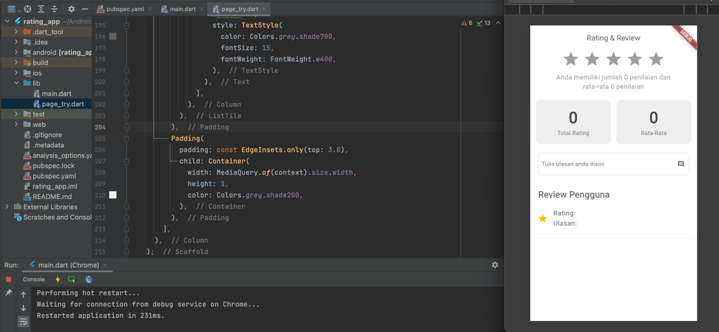

1. Pada widget InkWell, tambahkan onTap: showDialog: (){} (code dibawah), untuk memberikan pop up halaman ketika tombol bar ditekan

|  |
| --- |
| class _RatingScreenState extends State<RatingScreen> {  final TextEditingController _reviewController = TextEditingController();  @override  void dispose() {  _reviewController.dispose();  super.dispose();  }  @override  Widget build(BuildContext context) {  // kode selanjutnya  }  }  InkWell(  onTap: () {  showDialog(  context: context,  builder: (context) {  return AlertDialog(  shape: RoundedRectangleBorder(  borderRadius: BorderRadius.circular(10),  ),  backgroundColor: Colors.white,  elevation: 5,  content: SizedBox(  width: MediaQuery.of(context).size.width,  height: 350,  child: Padding(  padding: const EdgeInsets.only(left: 18.0, right: 18),  child: Center(  child: Column(children: [  SizedBox(height: 10),  Text(  "Tulis pengalaman anda disini",  textAlign: TextAlign.center,  style: TextStyle(  color: Colors.grey.shade800,  fontSize: 22,  fontWeight: FontWeight.w500,  ),  ),  SizedBox(height: 20),  Text(  'Berikan penilaian anda:',  style: TextStyle(  color: Colors.grey.shade500,  fontSize: 13,  fontWeight: FontWeight.w400,  ),  ),  SizedBox(height: 4.0),  Center(  child: RatingBar.builder(  initialRating: 0,  minRating: 1,  direction: Axis.horizontal,  allowHalfRating: true,  itemCount: 5,  itemPadding: const EdgeInsets.symmetric(horizontal: 4.0),  itemBuilder: (context, _) => const Icon(  Icons.star,  color: Colors.amber,  ),  onRatingUpdate: (rating) {},  ),  ),  SizedBox(height: 16.0),  Text(  'Tinggalkan masukkan anda:',  style: TextStyle(  color: Colors.grey.shade500,  fontSize: 13,  fontWeight: FontWeight.w400,  ),  ),  SizedBox(height: 8.0),  TextField(  controller: _reviewController,  decoration: InputDecoration(  hintText: 'Masukkan ulasan Anda',  border: OutlineInputBorder(),  ),  maxLines: 3,  ),  SizedBox(height: 20.0),  InkWell(  child: Container(  width: MediaQuery.of(context).size.width,  decoration: BoxDecoration(  color: Colors.amber,  borderRadius: BorderRadius.circular(5),  ),  child: Padding(  padding: const EdgeInsets.all(10),  child: Center(  child: Text(  'Submit',  style: TextStyle(  color: Colors.white,  fontSize: 12,  fontWeight: FontWeight.w600,  ),  ),  ),  ),  ),  onTap: () {  Navigator.pop(context);  },  ),  ]),  ),  ),  ),  );  },  );  },  child: Center(  child: Container(  height: 50,  width: MediaQuery.of(context).size.width * 0.91,  decoration: BoxDecoration(  border: Border.all(color: Colors.grey.shade300),  borderRadius: BorderRadius.circular(10),  ),  child: Padding(  padding: const EdgeInsets.only(left: 8.0, right: 10),  child: Row(  mainAxisAlignment: MainAxisAlignment.spaceBetween,  children: [  Text(  "Tulis ulasan anda disini",  style: TextStyle(  color: Colors.grey.shade600,  fontSize: 13,  fontWeight: FontWeight.w400,  ),  ),  Icon(  Icons.comment,  size: 16,  color: Colors.grey.shade600,  ),  ],  ),  ),  ),  ),  ) |

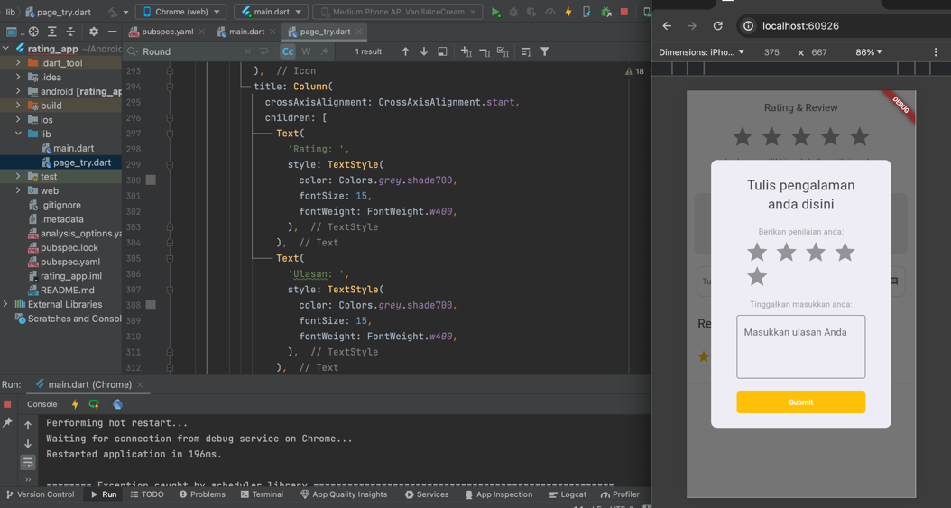

1. Tambahkan variabel dan fungssi baru

|  |
| --- |
| // Tambah Variabel  final TextEditingController _reviewController = TextEditingController();  double _currentRating = 0.0;  List<double> _ratings = [];  List<String> _reviews = [];  // Fungsi _submitRating  void _submitRating() {  setState(() {  _ratings.add(_currentRating);  _reviews.add(_reviewController.text);  _currentRating = 0.0;  _reviewController.clear();  });  }  // Fungsi _calculateAverageRating  double _calculateAverageRating() {  if (_ratings.isEmpty) {  return 0.0;  } else {  double totalRating = _ratings.reduce((value, element) => value + element);  return totalRating / _ratings.length;  } |

1. Tambahkan intialRating dan onRatingUpdate

|  |
| --- |
| //RatingBar.builder  RatingBar.builder(  initialRating: _calculateAverageRating(),  minRating: 1,  direction: Axis.horizontal,  allowHalfRating: true,  itemCount: 5,  itemPadding: const EdgeInsets.symmetric(horizontal: 4.0),  itemBuilder: (context, _) => const Icon(  Icons.star,  color: Colors.amber,  ),  onRatingUpdate: (rating) {  setState(() {  _currentRating = rating;  });  },  ),  // InkWell  showDialog(  context: context,  builder: (context) {  return AlertDialog(  shape: RoundedRectangleBorder(  borderRadius: BorderRadius.circular(10),  ),  backgroundColor: Colors.white,  elevation: 5,  content: SingleChildScrollView(  child: SizedBox(  width: MediaQuery.of(context).size.width,  child: Padding(  padding: const EdgeInsets.only(left: 18.0, right: 18),  child: Center(  child: Column(children: [  SizedBox(height: 10),  Text(  "Tulis pengalaman anda disini",  textAlign: TextAlign.center,  style: TextStyle(  color: Colors.grey.shade800,  fontSize: 22,  fontWeight: FontWeight.w500,  ),  ),  SizedBox(height: 20),  Text(  'Berikan penilaian anda:',  style: TextStyle(  color: Colors.grey.shade500,  fontSize: 13,  fontWeight: FontWeight.w400,  ),  ),  SizedBox(height: 4.0),  Center(  child: RatingBar.builder(  initialRating: _currentRating,  minRating: 1,  direction: Axis.horizontal,  allowHalfRating: true,  itemCount: 5,  itemPadding: const EdgeInsets.symmetric(horizontal: 4.0),  itemBuilder: (context, _) => const Icon(  Icons.star,  color: Colors.amber,  ),  onRatingUpdate: (rating) {  setState(() {  _currentRating = rating;  });  },  ),  ),  SizedBox(height: 16.0),  Text(  'Tinggalkan masukkan anda:',  style: TextStyle(  color: Colors.grey.shade500,  fontSize: 13,  fontWeight: FontWeight.w400,  ),  ),  SizedBox(height: 8.0),  TextField(  controller: _reviewController,  decoration: InputDecoration(  hintText: 'Masukkan ulasan Anda',  border: OutlineInputBorder(),  ),  maxLines: 3,  ),  SizedBox(height: 20.0),  InkWell(  child: Container(  width: MediaQuery.of(context).size.width,  decoration: BoxDecoration(  color: Colors.amber,  borderRadius: BorderRadius.circular(5),  ),  child: Padding(  padding: const EdgeInsets.all(10),  child: Center(  child: Text(  'Submit',  style: TextStyle(  color: Colors.white,  fontSize: 12,  fontWeight: FontWeight.w600,  ),  ),  ),  ),  ),  onTap: () {  _submitRating();  Navigator.pop(context);  },  ),  ]),  ),  ),  ),  ),  );  },  ) |

1. Tambahkan ListView.builder

|  |
| --- |
| SizedBox(height: 8),  Expanded(  child: ListView.builder(  itemCount: _ratings.length,  itemBuilder: (context, index) {  return Padding(  padding: const EdgeInsets.symmetric(vertical: 8.0, horizontal: 16.0),  child: Column(  crossAxisAlignment: CrossAxisAlignment.start,  children: [  Row(  children: [  RatingBarIndicator(  rating: _ratings[index],  itemBuilder: (context, index) => Icon(  Icons.star,  color: Colors.amber,  ),  itemCount: 5,  itemSize: 20.0,  direction: Axis.horizontal,  ),  SizedBox(width: 8.0),  Text(  _ratings[index].toString(),  style: TextStyle(  color: Colors.grey.shade700,  fontSize: 14,  fontWeight: FontWeight.w500,  ),  ),  ],  ), |

1. Tambahkan nilai rating dan rata-rata rating

|  |
| --- |
| Center(  child: Text(  "Anda memiliki jumlah ${_ratings.length} penilaian dan\nrata-rata ${_calculateAverageRating().toStringAsFixed(1)} penilaian",  textAlign: TextAlign.center,  style: TextStyle(  color: Colors.grey.shade500,  fontSize: 15,  fontWeight: FontWeight.w400,  ),  ),  ),  //Total  Text(  "${_ratings.length}",  style: TextStyle(  color: Colors.grey.shade800,  fontSize: 35,  fontWeight: FontWeight.w600,  ),  ),  //kalkulasi  Text(  "${_calculateAverageRating().toStringAsFixed(1)}",  style: TextStyle(  color: Colors.grey.shade800,  fontSize: 35,  fontWeight: FontWeight.w600,  ),  ),  //Tambah listview  Expanded(  child: ListView.builder(  itemCount: _ratings.length,  itemBuilder: (context, index) {  return Padding(  padding: const EdgeInsets.symmetric(vertical: 8.0, horizontal: 16.0),  child: Column(  crossAxisAlignment: CrossAxisAlignment.start,  children: [  Row(  children: [  RatingBarIndicator(  rating: _ratings[index],  itemBuilder: (context, index) => Icon(  Icons.star,  color: Colors.amber,  ),  itemCount: 5,  itemSize: 20.0,  direction: Axis.horizontal,  ),  SizedBox(width: 8.0),  Text(  _ratings[index].toString(),  style: TextStyle(  color: Colors.grey.shade700,  fontSize: 14,  fontWeight: FontWeight.w500,  ),  ),  ],  ),  SizedBox(height: 4.0),  Text(  _reviews[index],  style: TextStyle(  color: Colors.grey.shade700,  fontSize: 14,  ),  ),  Divider(color: Colors.grey.shade300),  ],  ),  );  },  ),  ), |

1. Terakhir, tambahkan nilai rating dan review per index dalam listview.builder untuk menampilkan keseluruhan rating dan review

|  |
| --- |
| import 'package:flutter/material.dart';  import 'package:flutter_rating_bar/flutter_rating_bar.dart';  class RatingScreen extends StatefulWidget {  const RatingScreen({super.key});  @override  State<RatingScreen> createState() => _RatingScreenState();  }  class _RatingScreenState extends State<RatingScreen> {  final TextEditingController _reviewController = TextEditingController();  double _currentRating = 0.0;  List<double> _ratings = [];  List<String> _reviews = [];  void _submitRating() {  setState(() {  _ratings.add(_currentRating);  _reviews.add(_reviewController.text);  _currentRating = 0.0;  _reviewController.clear();  });  }  double _calculateAverageRating() {  if (_ratings.isEmpty) {  return 0.0;  } else {  double totalRating = _ratings.reduce((value, element) => value + element);  return totalRating / _ratings.length;  }  }  @override  void dispose() {  _reviewController.dispose();  super.dispose();  }  @override  Widget build(BuildContext context) {  return Scaffold(  backgroundColor: Colors.white,  appBar: AppBar(  backgroundColor: Colors.white,  elevation: 0,  centerTitle: true,  title: Text(  'Rating & Review',  style: TextStyle(  color: Colors.grey.shade700,  fontSize: 17,  fontWeight: FontWeight.w500,  ),  ),  ),  body: Column(  crossAxisAlignment: CrossAxisAlignment.start,  children: [  Center(  child: RatingBar.builder(  initialRating: _calculateAverageRating(),  minRating: 1,  direction: Axis.horizontal,  allowHalfRating: true,  itemCount: 5,  itemPadding: const EdgeInsets.symmetric(horizontal: 4.0),  itemBuilder: (context, _) => const Icon(  Icons.star,  color: Colors.amber,  ),  onRatingUpdate: (rating) {  setState(() {  _currentRating = rating;  });  },  ),  ),  SizedBox(height: 10),  Center(  child: Text(  "Anda memiliki jumlah ${_ratings.length} penilaian dan\nrata-rata ${_calculateAverageRating().toStringAsFixed(1)} penilaian",  textAlign: TextAlign.center,  style: TextStyle(  color: Colors.grey.shade500,  fontSize: 15,  fontWeight: FontWeight.w400,  ),  ),  ),  SizedBox(height: 20),  Row(  mainAxisAlignment: MainAxisAlignment.spaceEvenly,  children: [  Container(  height: 100,  width: MediaQuery.of(context).size.width * 0.45,  decoration: BoxDecoration(  color: Colors.grey.shade200,  borderRadius: BorderRadius.circular(10),  ),  child: Column(  mainAxisAlignment: MainAxisAlignment.center,  crossAxisAlignment: CrossAxisAlignment.center,  children: [  Text(  "${_ratings.length}",  style: TextStyle(  color: Colors.grey.shade800,  fontSize: 35,  fontWeight: FontWeight.w600,  ),  ),  Text(  "Total Rating",  style: TextStyle(  color: Colors.grey.shade600,  fontSize: 13,  fontWeight: FontWeight.w400,  ),  ),  ],  ),  ),  Container(  height: 100,  width: MediaQuery.of(context).size.width * 0.45,  decoration: BoxDecoration(  color: Colors.grey.shade200,  borderRadius: BorderRadius.circular(10),  ),  child: Column(  mainAxisAlignment: MainAxisAlignment.center,  crossAxisAlignment: CrossAxisAlignment.center,  children: [  Text(  "${_calculateAverageRating().toStringAsFixed(1)}",  style: TextStyle(  color: Colors.grey.shade800,  fontSize: 35,  fontWeight: FontWeight.w600,  ),  ),  Text(  "Rata-Rata",  style: TextStyle(  color: Colors.grey.shade600,  fontSize: 13,  fontWeight: FontWeight.w400,  ),  ),  ],  ),  ),  ],  ),  SizedBox(height: 20),  InkWell(  onTap: () {  showDialog(  context: context,  builder: (context) {  return AlertDialog(  shape: RoundedRectangleBorder(  borderRadius: BorderRadius.circular(10),  ),  backgroundColor: Colors.white,  elevation: 5,  content: SingleChildScrollView(  child: SizedBox(  width: MediaQuery.of(context).size.width,  child: Padding(  padding: const EdgeInsets.only(left: 18.0, right: 18),  child: Center(  child: Column(children: [  SizedBox(height: 10),  Text(  "Tulis pengalaman anda disini",  textAlign: TextAlign.center,  style: TextStyle(  color: Colors.grey.shade800,  fontSize: 22,  fontWeight: FontWeight.w500,  ),  ),  SizedBox(height: 20),  Text(  'Berikan penilaian anda:',  style: TextStyle(  color: Colors.grey.shade500,  fontSize: 13,  fontWeight: FontWeight.w400,  ),  ),  SizedBox(height: 4.0),  Center(  child: RatingBar.builder(  initialRating: _currentRating,  minRating: 1,  direction: Axis.horizontal,  allowHalfRating: true,  itemCount: 5,  itemPadding: const EdgeInsets.symmetric(horizontal: 4.0),  itemBuilder: (context, _) => const Icon(  Icons.star,  color: Colors.amber,  ),  onRatingUpdate: (rating) {  setState(() {  _currentRating = rating;  });  },  ),  ),  SizedBox(height: 16.0),  Text(  'Tinggalkan masukkan anda:',  style: TextStyle(  color: Colors.grey.shade500,  fontSize: 13,  fontWeight: FontWeight.w400,  ),  ),  SizedBox(height: 8.0),  TextField(  controller: _reviewController,  decoration: InputDecoration(  hintText: 'Masukkan ulasan Anda',  border: OutlineInputBorder(),  ),  maxLines: 3,  ),  SizedBox(height: 20.0),  InkWell(  child: Container(  width: MediaQuery.of(context).size.width,  decoration: BoxDecoration(  color: Colors.amber,  borderRadius: BorderRadius.circular(5),  ),  child: Padding(  padding: const EdgeInsets.all(10),  child: Center(  child: Text(  'Submit',  style: TextStyle(  color: Colors.white,  fontSize: 12,  fontWeight: FontWeight.w600,  ),  ),  ),  ),  ),  onTap: () {  _submitRating();  Navigator.pop(context);  },  ),  ]),  ),  ),  ),  ),  );  },  );  },  child: Center(  child: Container(  height: 50,  width: MediaQuery.of(context).size.width * 0.91,  decoration: BoxDecoration(  border: Border.all(color: Colors.grey.shade300),  borderRadius: BorderRadius.circular(10),  ),  child: Padding(  padding: const EdgeInsets.only(left: 8.0, right: 10),  child: Row(  mainAxisAlignment: MainAxisAlignment.spaceBetween,  children: [  Text(  "Tulis ulasan anda disini",  style: TextStyle(  color: Colors.grey.shade600,  fontSize: 13,  fontWeight: FontWeight.w400,  ),  ),  Icon(  Icons.comment,  size: 16,  color: Colors.grey.shade600,  ),  ],  ),  ),  ),  ),  ),  SizedBox(height: 30),  Padding(  padding: const EdgeInsets.only(left: 18.0),  child: Text(  "Review Pengguna",  style: TextStyle(  color: Colors.grey.shade800,  fontSize: 20,  fontWeight: FontWeight.w500,  ),  ),  ),  SizedBox(height: 8),  Expanded(  child: ListView.builder(  itemCount: _ratings.length,  itemBuilder: (context, index) {  return Padding(  padding: const EdgeInsets.symmetric(vertical: 8.0, horizontal: 16.0),  child: Column(  crossAxisAlignment: CrossAxisAlignment.start,  children: [  Row(  children: [  RatingBarIndicator(  rating: _ratings[index],  itemBuilder: (context, index) => Icon(  Icons.star,  color: Colors.amber,  ),  itemCount: 5,  itemSize: 20.0,  direction: Axis.horizontal,  ),  SizedBox(width: 8.0),  Text(  _ratings[index].toString(),  style: TextStyle(  color: Colors.grey.shade700,  fontSize: 14,  fontWeight: FontWeight.w500,  ),  ),  ],  ),  SizedBox(height: 4.0),  Text(  _reviews[index],  style: TextStyle(  color: Colors.grey.shade700,  fontSize: 14,  ),  ),  Divider(color: Colors.grey.shade300),  ],  ),  );  },  ),  ),  ],  ),  );  }  } |

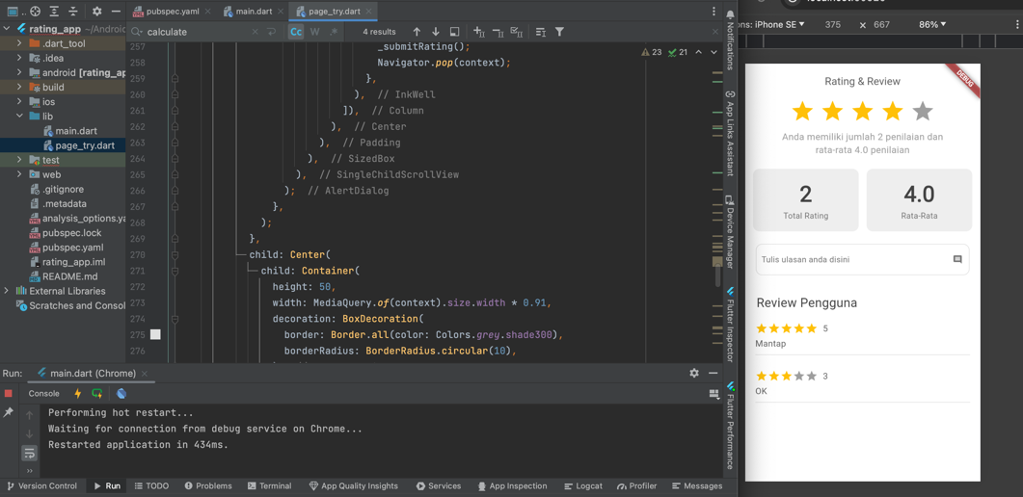

* 1. **Push Code to GitHub** <https://github.com/adelianurlinap/Prak_PBM.git>
     1. Clone Repository yang telah dibuat :

|  |
| --- |
| git clone https://github.com/adelianurlinap/Prak_PBM.git |

* + 1. Add dan commit

|  |
| --- |
| git add .  git commit -m "Tugas9" |

* + 1. Push code

|  |
| --- |
| git push |

1. **Kesimpulan**

Pada tugas 10 ini, telah dilakukan praktek untuk membuat rating_app

1. **Referensi**

modul prak11